localization architecture:

Localization — How It Works Internally
The Full Stack Picture
Browser URL: /am/home
↓
Next.js Middleware (routing)
↓
i18n/request.ts (server-side, loads messages)
↓
layout.tsx (NextIntlClientProvider injects messages)
↓
React Components (useTranslations() reads them)
↓
spring Boot API (serves Amharic/Oromoo strings)

Layer 1 — URL-Based Locale Detection (i18n/routing.ts)
This is the entry point. It tells Next.js which URL prefixes map to which locale:
ts
// i18n/routing.ts
export const routing = defineRouting({
locales: ['en', 'am', 'om'],
defaultLocale: 'en'
});
When a user visits /am/home, Next.js extracts am from the URL and sets it as the active locale for that entire request. The [locale] folder in app/[locale]/ is what makes this work — it's a Next.js dynamic segment.

Layer 2 — Middleware (middleware.ts)
Next.js runs a middleware file on every request before rendering. next-intl provides a createNavigation middleware that:
- Reads the URL (/am/home)
- Extracts the locale (am)
- If someone visits /home with no locale prefix, redirects them to /en/home (the default)
- Sets the locale in the request headers so the rest of the stack can read it

Layer 3 — Message Loading (i18n/request.ts)
This runs server-side for every page request. It's the bridge between your translation files and next-intl:
ts
export default getRequestConfig(async ({ requestLocale }) => {
const locale = await requestLocale; // e.g. "am"

// 1. Load local JSON fallback (always available, even if backend is down)
const localMessages = (await import(`../messages/${locale}.json`)).default;

// 2. Fetch live translations from Spring Boot
const res = await fetch(`http://localhost:8083/api/translations/${locale}`);
const flatMessages = await res.json();
// {"nav.home": "ቤት", "auth.login": "ግባ"}

// 3. Unflatten dot-notation → nested object
const remoteMessages = unflatten(flatMessages);
// {"nav": {"home": "ቤት"}, "auth": {"login": "ግባ"}}
// 4. Deep merge (remote values override local, but both contribute)
return {
locale,
messages: deepMerge(localMessages, remoteMessages)
};
});
The resulting messages object looks like:
json
{
"nav": { "home": "ቤት", "about": "ስለ", ... },
"auth": { "login": "ግባ", "register": "ምዝገባ" },
"map": { "title_prefix": "ለሁሉም ያገለግላል" }
}

Layer 4 — Provider Injection (app/[locale]/layout.tsx)
The layout wraps the entire app with NextIntlClientProvider, passing down the messages loaded in Layer 3:
tsx
const messages = await getMessages(); // Calls i18n/request.ts internally
return (
<NextIntlClientProvider messages={messages}>
<Navbar />
{children} {/* Every page and component inside here gets the messages */}
</NextIntlClientProvider>
);
This is the React Context mechanism. The messages are loaded once on the server, embedded into the HTML response, and made available to every client component through context — no extra network calls from the browser.

Layer 5 — Components Consuming Translations (useTranslations())
Any component (client or server) can now read translations:
tsx
// Client Component
const t = useTranslations();
t('nav.home') // → "ቤት" (in /am/ locale)
t('nav.home') // → "Home" (in /en/ locale)
t('map.title_prefix')// → "ለሁሉም ያገለግላል"
Internally useTranslations():
- Reads the messages object from the NextIntlClientProvider context
- Walks the dot path: nav → picks the nav object → home → returns "ቤት"
- If the key is not found, it returns the key name itself (why you saw nav.home when the key was missing!)

Layer 6 — Spring Boot Backend (TranslationService.java)
The backend is the source of truth for Amharic and Afaan Oromoo translations:
java
// GET /api/translations/am
public Map<String, String> getAllTranslationsForLocale(String locale) {
File file = new File("src/main/resources/messages_am.properties");
Properties props = new Properties();
props.load(new FileReader(file));

// Returns: {"nav.home": "ቤት", "auth.login": "ግባ", ...}
return convertToMap(props);
}
When the admin saves from the dashboard:
java
// POST /api/translations { locale: "am", updates: {"nav.home": "ቤት"} }
public void saveTranslation(String key, String locale, String value) {
File file = new File("src/main/resources/messages_am.properties");
Properties props = loadProps(file);
props.setProperty(key, value); // Add/update the key
props.store(new FileWriter(file)); // Write back to disk
}
This means translations persist to disk and survive server restarts.

The Complete Request Lifecycle
User visits /am/home
↓
Middleware extracts locale = "am"
↓
layout.tsx calls getMessages()
↓
i18n/request.ts:
→ loads messages/am.json (empty/partial fallback)
→ fetches /api/translations/am from Spring Boot
→ Spring Boot reads messages_am.properties → returns flat map
→ unflatten() → nested JSON
→ deepMerge(local, remote) → final messages bundle
↓
NextIntlClientProvider receives messages bundle
↓
Navbar renders: t('nav.home') → looks up messages.nav.home → "ቤት"
MapSection renders: t('map.title_prefix') → "ለሁሉም ያገለግላል"
↓
HTML sent to browser with correct Amharic text already rendered

Key Design Decisions
Decision | Why
messages.properties on disk | No database needed, survives restarts, editable by devs directly
en.json as local fallback | English always works even if Spring Boot is down
cache: 'no-store' on fetch | Admin dashboard changes immediately visible
deepMerge instead of spread | Remote keys update individual values without wiping sibling keys
URL-prefix routing /am/ | Clean SEO-friendly URLs, locale is always explicit

Layer 1 — URL Determines the Language (i18n/routing.ts)
💡 The URL itself decides the language.
Example:
- /am/home → Amharic
- /om/home → Afaan Oromoo
- /en/home → English
Next.js checks the first URL segment and sets the active locale.
📌 You don’t need to detect anything manually — the URL does the job.
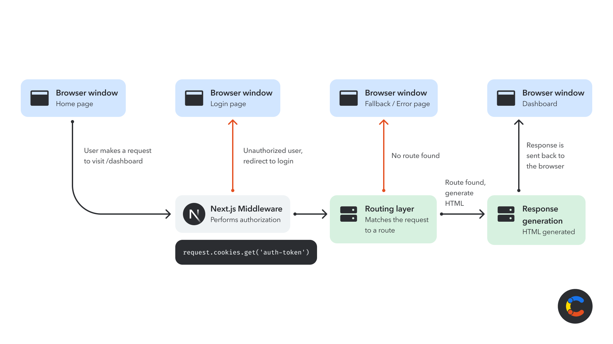
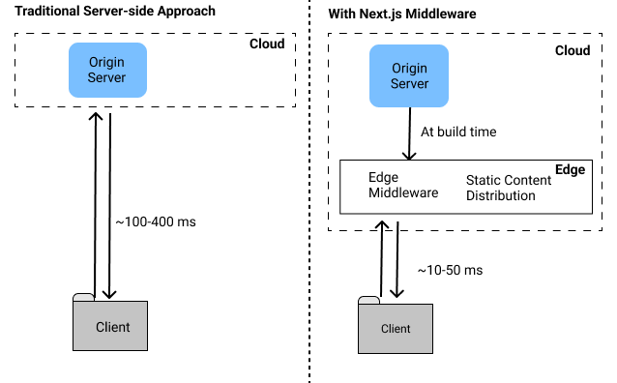

Middleware runs before any page loads.
It does 3 things:
1️⃣ Read the URL → finds the locale (am)
2️⃣ If no locale → redirect /home → /en/home
3️⃣ Store locale inside the request so every other step knows about it
📌 Think of middleware as the “security guard” checking language at the door.

🔹 Layer 3 — Load Messages (i18n/request.ts)
This is the heart of the whole system.
It does:
1. Load local JSON (fallback)
Always present — even if backend is offline.
2. Fetch updated translations from Spring Boot
Example returned data:
{
"nav.home": "ቤት",
"auth.login": "ግባ"
}
3. Convert flat keys → nested objects
nav.home →
{
nav: { home: "ቤት" }
}
4. Deep merge (remote wins, but fallback fills missing keys)
You end up with a complete translation tree.
📌 This ensures the UI never breaks, even if some translations are missing.

Layer 4 — Inject Messages Into React (layout.tsx)
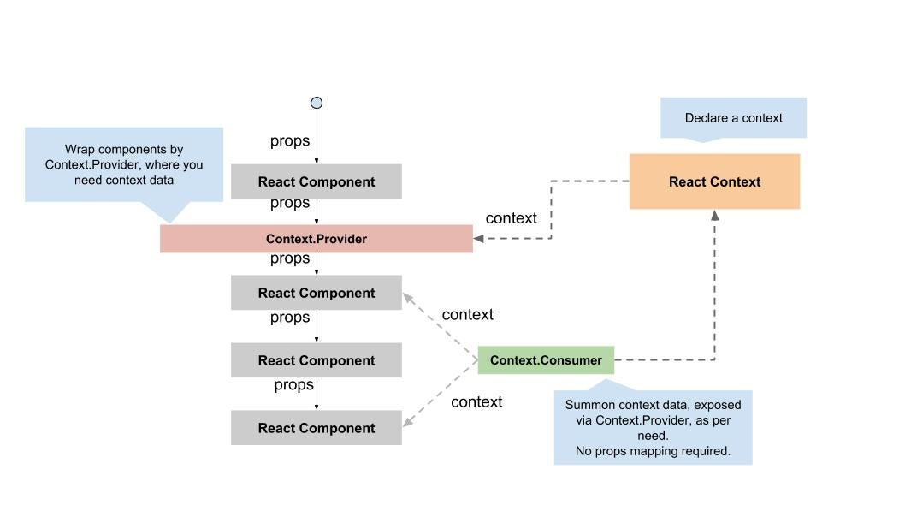
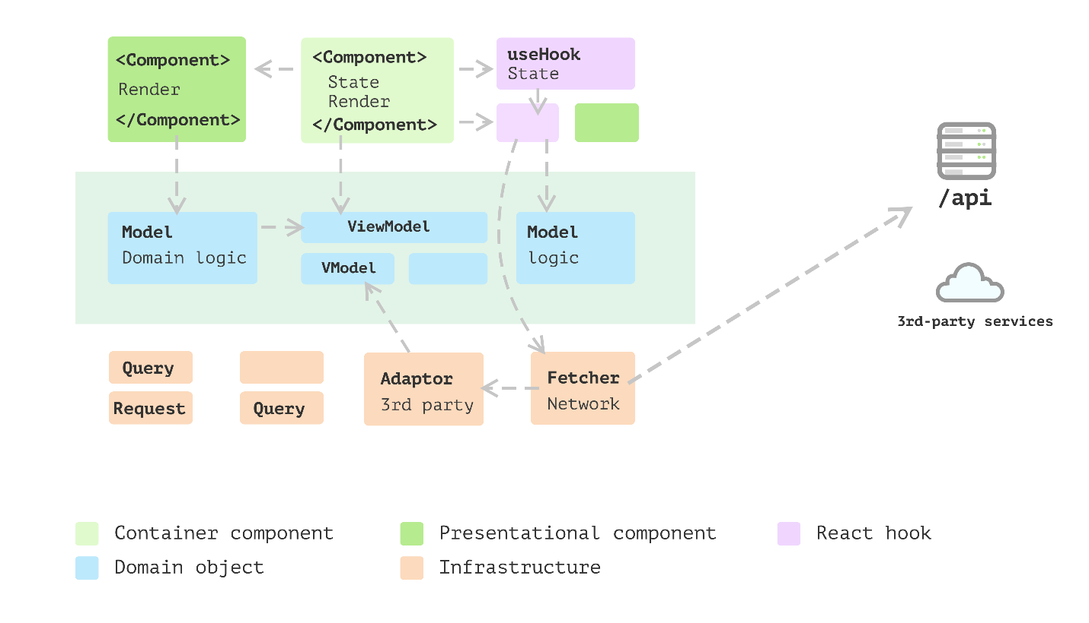

Inside layout.tsx:
- You call getMessages()
- You wrap the app inside NextIntlClientProvider
- All components inside can now read translations
It’s like giving every React component a dictionary for its language.
📌 React Context silently carries translation messages everywhere.

🔹 Layer 5 — Components Use useTranslations()
Example:
const t = useTranslations();
t("nav.home");
Internally:
- Looks into the messages object
- Goes to nav
- Finds home
- Returns "ቤት"
If a key does NOT exist → returns the key itself
→ That’s why you saw "nav.home" appear on the UI.

Layer 6 — Spring Boot Provides Dynamic Translations

Spring Boot loads messages_am.properties and returns flat keys:
nav.home=ቤት
auth.login=ግባ
When an admin updates a translation:
- Spring Boot writes into .properties files
- Files are saved permanently
- No database required
📌 Spring Boot is the translation storage + editor.

Putting It All Together — One Clear Flow
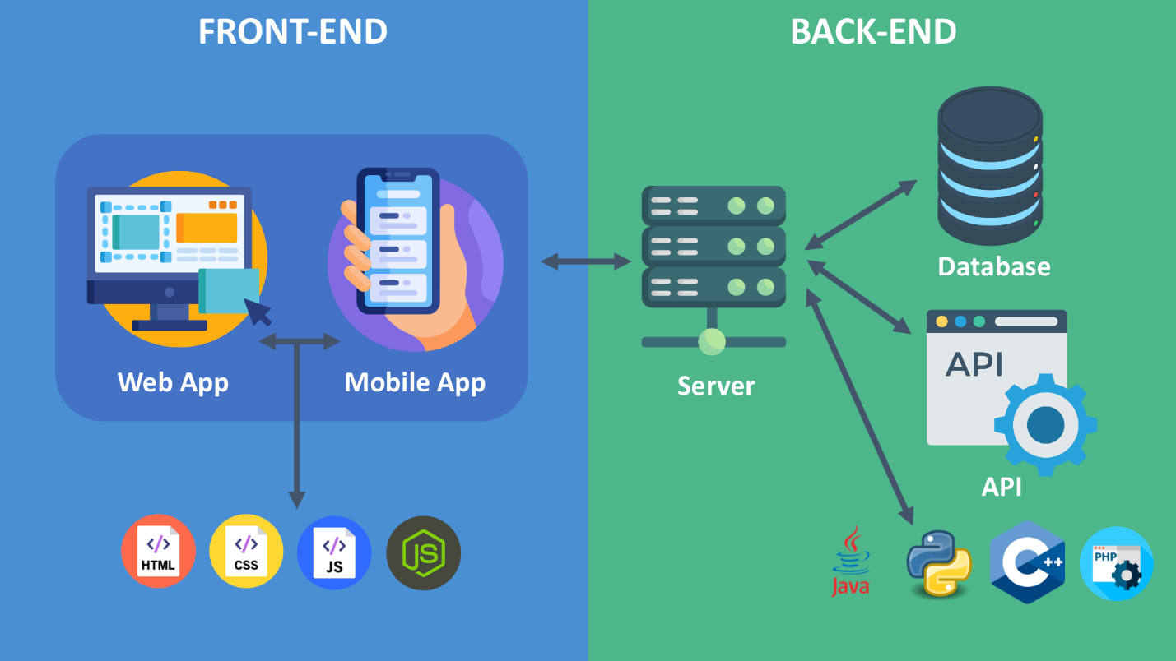

User visits: /am/home
1️⃣ Middleware:
→ sees /am
→ sets locale = am
2️⃣ layout.tsx:
→ calls getMessages()
3️⃣ i18n/request.ts:
→ loads local fallback JSON
→ fetches Spring Boot translations
→ merges them into final messages
4️⃣ Provider:
→ gives messages to React components
5️⃣ Components:
→ call t("nav.home")
→ display "ቤት"
6️⃣ Browser receives HTML fully translated.
📌 Your system translates the page BEFORE it reaches the browser.

The Whole System in One Sentence
When the user visits /am/..., Next.js detects the language from the URL, the middleware confirms it, translations are loaded and merged from JSON + Spring Boot, injected into React context, and then every component shows the correct text using useTranslations().

the dynamic translation specifically happens when we pass variables into our translation strings.
In app/[locale]/admin/sectors/page.tsx, take a look at the

handleDelete method at line 33:
typescript
const handleDelete = async (id: string, name: string) => {
if (confirm(t('delete_confirm', { name }))) { // <-- Dynamic translation here!
try {
// ...

Why is this dynamic?
When the user clicks the delete button for a specific Bureau (e.g., "Ministry of Health"), we need the confirmation dialog to inject that specific Bureau's name into the translated sentence.
- In our

messages/en.json, the string has a placeholder {name}:
json
"delete_confirm": "Are you sure you want to delete {name}?"
- In our

messages/am.json, the sentence structure is different, but the placeholder {name} remains:
json
"delete_confirm": "{name}ን ለመሰረዝ እርግጠኛ ነዎት?"
When we call

t('delete_confirm', { name }), next-intl dynamically constructs the string on the fly!
- For English, it will render: "Are you sure you want to delete Ministry of Health?"
- For Amharic, it will render: "Ministry of Healthን ለመሰረዝ እርግጠኛ ነዎት?"
This is why we had to change the hardcoded template literal confirm(Are you sure you want to delete ${name}?) to the next-intl approach, so the application can dynamically inject the variable securely regardless of the target language's grammatical structure.

How Keys and Values Work — No Database Needed
The
.properties File Format
A
.properties file is just a simple text file with key=value pairs:
properties
# messages.properties (English)
nav.home=Home
nav.about=About
auth.login=Login
map.title_prefix=Serving All of
properties
# messages_am.properties (Amharic)
nav.home=ቤት
nav.about=ስለ እኛ
auth.login=ግባ
map.title_prefix=ለሁሉም ያገለግላል
The key (nav.home) is the same in ALL files. Only the value changes per language. The system finds the right value by combining the key + the current locale.

How it flows — step by step
Step 1 — Reading (every page load):
User visits /am/home
→ Spring Boot reads messages_am.properties
→ Returns: { "nav.home": "ቤት", "auth.login": "ግባ" }
→ Next.js unflatten: { "nav": { "home": "ቤት" }, "auth": { "login": "ግባ" } }
→ t('nav.home') → "ቤት" ✅

Step 2 — Writing (when admin saves):
Admin types "ቤት" for key "nav.home" → clicks Save Changes
→ POST /api/translations { locale: "am", updates: { "nav.home": "ቤት" } }
→ Spring Boot opens messages_am.properties
→ Sets: nav.home=ቤት
→ Saves file to disk

Step 3 — Next page load:
Same flow as Step 1 → now reads the updated value from disk
Why no database is needed
The
.properties file IS the storage. Think of it like this:
Database concept | File equivalent
Table | .properties file
Row | One key=value line
Column | The locale suffix (_am, _om)
INSERT / UPDATE | props.setProperty(key, value) + write file
SELECT | props.load(reader) + read all keys
Java's built-in java.util.Properties class handles reading/writing these files natively
no ORM, no SQL, no schema migrations needed. The file just sits on disk and Spring Boot reads it fresh every time the API is called.

Enhanced & Simplified Explanation of How next-intl Works
The application uses a library called next-intl to manage internationalization (i18n). Below is a simplified explanation of how it works, using your recent updates as an example.

1. Translation Files (JSON Dictionaries)
All translated text is stored inside the messages/ folder.
Each language has its own JSON file:
- en.json → English
- am.json → Amharic
- om.json → Oromiffa
Inside each file, translations are grouped using namespaces (just objects inside the JSON).
Example from messages/en.json:

{
"BureauRegistry": {
"title": "Bureau Registry",
"description": "Manage government bureaus and departments.",
"delete_confirm": "Are you sure you want to delete {name}?"
}
}
The matching Amharic version in messages/am.json:
{
"BureauRegistry": {
"title": "የቢሮ ምዝገባ",
"description": "የመንግስት ቢሮዎችን እና ክፍሎችን ያስተዳድሩ።",
"delete_confirm": "{name}ን ለመሰረዝ እርግጠኛ ነዎት?"
}
}
The keys must match across languages so React can pull the correct string.

2. Loading Translations Inside React Components
In your components (for example: app/[locale]/admin/sectors/page.tsx), you use the useTranslations hook from next-intl.
import { useTranslations } from "next-intl";
export default function SectorsListPage() {
// Load the “BureauRegistry” namespace
const t = useTranslations('BureauRegistry');
}
This tells next-intl:
➡️ “Use the translations inside the BureauRegistry section of the current language file.”

3. Replacing Hardcoded Text
Instead of writing static English text like this:
<h1 className="text-2xl font-bold">Bureau Registry</h1>
You use the translation function:
<h1 className="text-2xl font-bold">{t('title')}</h1>
Because the URL contains a locale (e.g., /en/admin/sectors or /am/admin/sectors), next-intl automatically:
- Detects which language the user is viewing.
- Loads the correct JSON file.
- Replaces t('title') with the translated value.

4. Using Variables Inside Translations
Sometimes translations include dynamic data—like the name of a Bureau.
That’s why JSON uses placeholders like {name}.
Instead of:
confirm(`Are you sure you want to delete ${name}?`)
You can write:
confirm(t('delete_confirm', { name: sector.name }));
next-intl automatically:
- Reads the localized string from the active JSON file
- Inserts the sector.name into the {name} placeholder
- Keeps the correct grammar for each language

Here’s the whole system in one simple explanation:
- Translations live in /messages/*.json files.
- Each component loads the needed section using useTranslations('Namespace').
- Instead of writing plain text, you use t('key').
- next-intl picks the correct language based on the URL locale.
- You can insert dynamic values using t('key', { var: value }).
This makes the whole app fully multilingual without manually writing text for each language in every component.

1. User Changes the Language
When the user switches languages in your dropdown, your app doesn’t "translate" anything yet.
Instead, the browser URL changes:
/en/admin/sectors → /am/admin/sectors
This URL change is the trigger for the entire translation process.

2. Next.js Detects the Locale From the URL
Your folder structure looks like this:
app/
[locale]/
admin/
sectors/
page.tsx
The [locale] part means:
- If the URL starts with /en, Next.js renders from app/en/...
- If the URL starts with /am, it renders from app/am/...
So the URL tells Next.js which language folder to use.
No database involved. No API call.

3. next-intl Loads the Correct JSON File
next-intl now sees:
“Oh, the locale is am. I will load am.json.”
It immediately loads your translation dictionary from:
messages/am.json
This happens INSTANTLY, in the browser, without calling Spring Boot.
Example:
am.json
{
"BureauRegistry": {
"title": "የቢሮ ምዝገባ"
}
}

4. Your React Component Starts Rendering
Inside your page component, you call:
const t = useTranslations('BureauRegistry');
This means:
“Give me the part of am.json that belongs to ‘BureauRegistry’.”
Now your React component has access to the translations.

5. React Swaps the Text While Rendering
Whenever React hits code like:
<h1>{t('title')}</h1>
It asks:
“What is title in the current language?”
If the user is on /am/... → it returns:
“የቢሮ ምዝገባ”
If the user is on /en/... → it returns:
“Bureau Registry”
This is how the UI text changes dynamically.

6. Database Data Appears Untranslated
At the same time, your page fetches bureaus:
const bureaus = await getAllBureaus();
A bureau name like:
"Oromia Health Bureau"
is user-saved content, stored in your database.
So React displays it exactly as it is:
<td>{sector.name}</td>
No translation is applied here — because user-entered data is not part of your JSON dictionaries.

Summary — The Core Magic
Next.js + next-intl works because of Separation of Concerns:
🧩 1. Translated UI (from JSON files)
- Menu items
- Labels
- Buttons
- Headings
- Error messages
- Table headers
- Form placeholders
These come from en.json, am.json, etc.
⚡ Loaded instantly
⚡ No backend calls
⚡ Fully controllable by developers

2. User Data (from your database — NOT translated)
Anything typed by an admin or user:
- Bureau names
- Sector names
- Region names
- Codes
- Descriptions
These values stay the same in all languages.
Because:
The backend is not a translation system — only your UI is.

Complete Flow Example
Let's trace what happens when a user visits /am/admin/sectors:
Step 1: URL to Locale
- Next.js detects /am prefix
- Sets locale = "am"
Step 2: Loading Translations
typescript
// i18n/request.ts runs
locale = "am"

// Loads local JSON
localMessages = require("../messages/am.json")

// Fetches from backend
fetch("http://localhost:8083/api/translations/am")
// Returns: { "nav.home": "ዋና ገጽ", "auth.login": "ግባ", ... }

// Converts flat to nested
remoteMessages = unflatten({
"nav.home": "ዋና ገጽ",
"auth.login": "ግባ"
}) // → { nav: { home: "ዋና ገጽ" }, auth: { login: "ግባ" } }

// Merges (remote overrides local)
messages = deepMerge(localMessages, remoteMessages)
Step 3: Rendering Component
tsx
// In SectorsListPage
const t = useTranslations('BureauRegistry');

// t('title') looks in:
// 1. messages.BureauRegistry.title (from merged object)
// Result: "የቢሮ ምዝገባ" (from messages_am.properties via API)
Step 4: Admin Updates Translation
- Admin edits "Service Registry" title in Amharic
- Frontend sends POST to /api/translations
json
{
"locale": "am",
"updates": {
"ServiceRegistry.title": "አዲስ እሴት"
}
}
- Backend updates messages_am.properties
- Next refresh fetches new value

Priority Order (Which value wins?)
When resolving t('BureauRegistry.title'):
- Dynamic Remote (from API) - Highest priority
  - Comes from .properties files
  - Editable via admin dashboard
- Static Local (from JSON) - Fallback
  - Comes from messages/xx.json
  - Not editable via dashboard
- Hardcoded Default - Last resort
  - useCodeAsDefaultMessage(true) in Spring
  - Shows the key itself if no translation found

Key Files Summary
File | Purpose
i18n/routing.ts | Defines available locales
i18n/request.ts | Loads & merges translations
TranslationService.java | Backend CRUD for translations
TranslationController.java | API endpoints
messages/*.json | Static fallback translations
src/main/resources/messages*.properties | Dynamic translations
Why static why translation?

Static Translations (JSON files in Next.js)
json
// messages/en.json - STATIC
{
"BureauRegistry": {
"title": "Bureau Registry",
"description": "Manage government bureaus"
}
}
Why "static"?
- Bundled at build time: These JSON files are included when you run npm run build
- Cannot change without redeploy: To update text, you must:
  - Edit the JSON file
  - Rebuild the application
  - Redeploy to server
- Part of the codebase: Lives in your Git repository, version controlled
- No database involved: Just files on disk in the frontend

Dynamic Translations (.properties files in Spring Boot)
properties
# messages_am.properties - DYNAMIC
auth.login=ግባ
nav.home=ዋና ገጽ
Why "dynamic"?
- Loaded at runtime: Fetched via API when user visits the page
- Can change anytime: Admin can update via dashboard → changes appear on next page refresh
- No rebuild needed: Edit through UI, save to backend, immediately available
- Separate from codebase: Stored on backend server, can be modified independently
- Real-time updates: Changes reflect without redeploying the application
- The Hybrid Approach - Why Both?
- text
- User Request → Load Static JSON (fallback) → Fetch Dynamic (override) → Render

Real-world Example:
Scenario 1: Static Only
json
// messages/en.json (static)
{
"BureauRegistry": {
"title": "Bureau Registry" // Hardcoded at build time
}
}
❌ To change to "Department Registry":
- Must modify JSON
- Rebuild frontend
- Redeploy application
- Takes 10-30 minutes minimum
Scenario 2: Dynamic Only
properties
# messages.properties (dynamic)
BureauRegistry.title=Bureau Registry # Can change anytime
✅ To change to "Department Registry":
- Admin logs into dashboard
- Types new value
- Clicks save
- Refreshes page → changed instantly (30 seconds)

Why Keep Static Files Then?
typescript
// i18n/request.ts - The merge strategy
return {
messages: deepMerge(
localMessages, // Static JSON (fallback)
remoteMessages // Dynamic API (override)
)
};
**1. Reliability (Offline First)
typescript
// If backend API is down:
try {
remoteMessages = await fetch('/api/translations'); // May fail
} catch {
// Still have static JSON as fallback!
// User still sees translations, just not the latest dynamic ones
}
**2. Development Speed
bash
# As a developer, I can:
- Work locally without running Spring Boot backend
- Just edit JSON files and see changes with hot reload
- Commit working translations to Git
**3. Default Values
json
// messages/am.json (static - provides baseline)
{
"BureauRegistry": {
"title": "የቢሮ ምዝገባ" // Good translation
}
}

// Later, admin can override via dashboard if needed
// But if they don't, static version is used
**4. Performance
typescript
// Static JSON is served instantly from CDN/browser cache
// No need to wait for API call for basic content
// API call happens in background and merges
Visual Comparison
text
STATIC TRANSLATIONS (messages/*.json)
├── en.json ──┐
├── am.json ──┼─── Bundled with app ────┐
├── om.json ──┘ │
▼
User sees
▲
DYNAMIC TRANSLATIONS (backend) │
├── messages.properties ──┐ │
├── messages_am.properties─┼─── API call ────┘
├── messages_om.properties─┘
When to Use Each
Use STATIC when:
typescript
// 1. Core UI elements that rarely change
"button.save": "Save Changes"

// 2. Development/testing
"debug.message": "This is a test"

// 3. When backend isn't ready
// Work on frontend independently

// 4. Sensible defaults
"error.404": "Page not found"
Use DYNAMIC when:
typescript
// 1. Content that changes frequently
"announcement.text": "New service launched!"

// 2. Non-technical admins need to edit
"homepage.welcome": "Welcome message"

// 3. Regional variations
"service.123.name": "Business License"

// 4. A/B testing different messages
"promo.banner": "Limited time offer!"
Real Example from Your Code
Look at SectorsListPage.tsx:
tsx
export default function SectorsListPage() {
const t = useTranslations('BureauRegistry');

// This 'title' could come from:
// 1. STATIC: messages/en.json (if API fails)
// 2. DYNAMIC: messages.properties (if admin overrode it)
return <h1>{t('title')}</h1>;
}
If an admin wants to change "Bureau Registry" to "Department Registry":
- Static only: Can't without redeploy
- Dynamic: Can change immediately via admin dashboard
- Hybrid: Static provides default, dynamic allows override
The "Dynamic" Part Explained

✅ 1. The Trigger — Admin Registers a New Service
Imagine an admin creates a new service using a form.
Example: "Tax Registration".
When they click Save, the information goes to the backend → specifically into ServiceRegistryService.java.
✔️ What the backend does
Inside your mapToEntity() method, the backend does NOT store the English text directly.
Instead, it creates a unique translation key, something like:
service.a1b2c3d4.title
This key becomes the "ID" for the service title across all languages.
✔️ What gets saved in the database?
❌ Not: "Tax Registration"
✔️ Instead: "service.a1b2c3d4.title"
So the database stores only the key, not the real text.
✔️ Now the English text needs to be saved somewhere
The backend immediately writes the English value into the English translation file:
messages.properties (EN)
service.a1b2c3d4.title = Tax Registration
✔️ What about Amharic and Oromoo?
They do not exist yet.
Those files have no entry for this key:
messages_am.properties → key missing
messages_om.properties → key missing
So at this moment:
Key | EN | AM | OM
service.a1b2c3d4.title | ✔️ Exists | ❌ Missing | ❌ Missing
This missing data is what will show up as Untranslated later.

🧩 2. Next.js Asks for All Translations
When the admin opens:
/admin/translations
The frontend runs:
const data = await getAllTranslations();
This calls the Spring Boot backend.
✔️ What the backend does now
TranslationService reads all three .properties files:
- messages.properties → English
- messages_am.properties → Amharic
- messages_om.properties → Oromoo
And merges them into one unified object, grouped by key.
So it returns something like:
{
"service.a1b2c3d4.title": {
"en": "Tax Registration",
"am": null,
"om": null
}
}
This tells the frontend:
- There is an English translation
- Amharic = missing
- Oromoo = missing
Exactly what we need to identify "Untranslated" items.

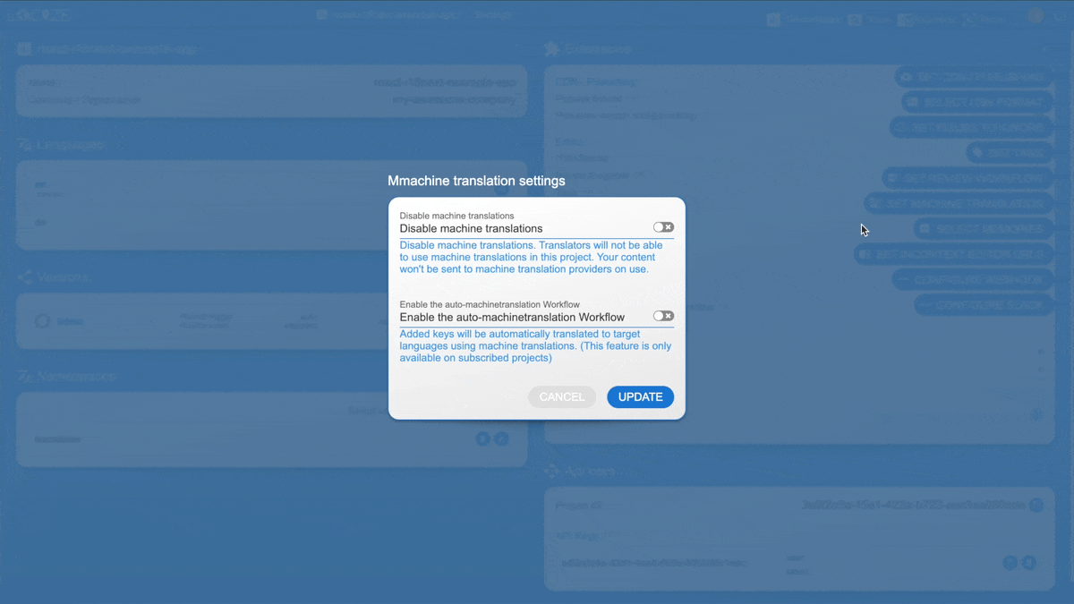
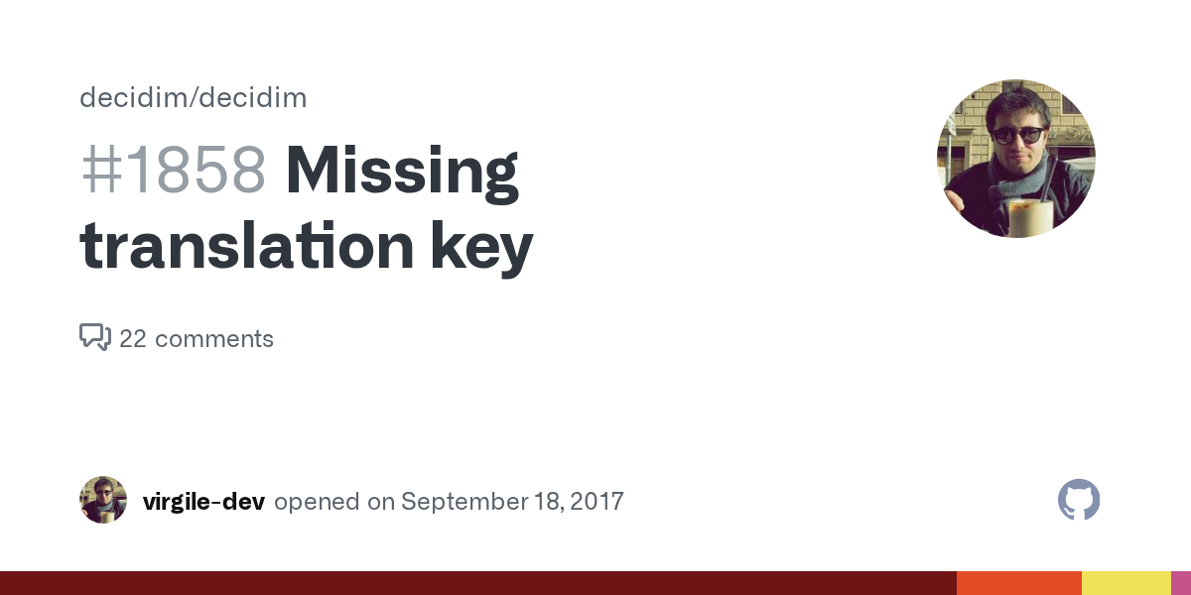
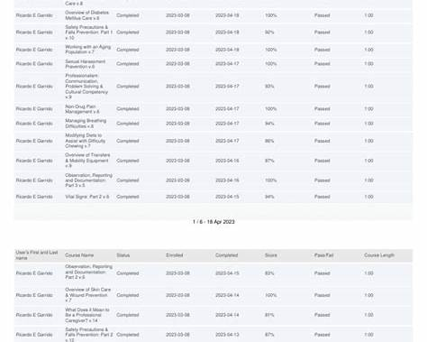
4
🔍 3. Detecting "Untranslated" Items in React
Inside your React code, around line 91, there is logic that checks each key:
const isTranslatedAm = (tr.am || "").trim() !== "";
const isTranslatedOm = (tr.om || "").trim() !== "";
const isFullyTranslated = isTranslatedAm && isTranslatedOm;
✔️ Explanation
- If Amharic has text → isTranslatedAm = true
- If Oromoo has text → isTranslatedOm = true
- If BOTH are true → it's fully translated
✔️ When the admin chooses the "Untranslated" tab
The UI filters:
Show only items where isFullyTranslated === false
For our service:
- English: exists
- Amharic: ❌ missing
- Oromoo: ❌ missing
So:
isFullyTranslated = false
➡️ Therefore, it appears inside Untranslated list.

✍️ 4. Admin Translates the Missing Fields
In the dashboard, the admin enters:
Language | Value
Amharic | የታክስ ምዝገባ
Oromoo | Galmee Taaksi
Then clicks Save Changes.
The frontend sends this to:
POST /api/translations
✔️ What backend does now
Spring Boot writes:
messages_am.properties
service.a1b2c3d4.title = የታክስ ምዝገባ
messages_om.properties
service.a1b2c3d4.title = Galmee Taaksi
Now all languages have the value.
Key | EN | AM | OM
service.a1b2c3d4.title | ✔️ | ✔️ | ✔️
Next time the admin opens the page:
isFullyTranslated = true
So the service moves from Untranslated → Translated.

🎉 Final Summary (Super Simple)
Here is the entire flow in one sentence:
When a new service is created, Spring Boot stores only a translation key in the database, saves the English text, leaves Amharic/Oromoo empty, the frontend detects missing fields, shows them in the “Untranslated” tab, and once the admin fills them, the backend writes them to the respective .properties files — making the item fully translated.

Right now, the untranslated fields do not auto-populate if you simply add a new model.
If you look closely at your

ServiceRegistryService.java, the exact reason the

ServiceRegistry appears in the dashboard is because someone explicitly wrote hardcoded logic to generate a translation key and save it to the

.properties file every time a new service is created:
java
// Hardcoded in ServiceRegistryService.java
String translationKey = "service." + dto.getId() + ".title";
entity.setTitle(translationKey);
translationService.saveTranslation(translationKey, "en", dictionary.get("en"));
If you add a new model (like Category or Product), you would currently have to copy and paste that exact logic into the CategoryService and ProductService.
Since this is a microservice project, doing this manually for every new service is not sustainable. Furthermore, because microservices run inside isolated environments (like Docker containers), writing translations to local

.properties files on the disk is dangerous (if a container restarts, you lose all translations!).
How to make this Generic and Auto-Populating
To easily extend this across all your future microservices, you need to solve two architectural challenges:
- How to Auto-Populate Keys (Without writing code in every service)
- Where to Store the Translations (Microservice Storage)

1. Auto-Populating Keys via Custom Annotations (AOP/JPA)
Instead of manually generating keys in your

Service layer, you should create a custom annotation (e.g., @TranslatableField). You can place this annotation on any database column in any model that needs to be translated.
java
@Entity
public class Category {
@Id
private String id;
@TranslatableField // <-- You just add this!
private String name;

@TranslatableField
private String description;
}
Then, you create a generic JPA Entity Listener (@PrePersist and @PreUpdate). This listener runs automatically right before any entity is saved to the database. It will:
- Scan the entity for any fields marked with @TranslatableField.
- Extract the English text the user typed (e.g., "Health Core").
- Automatically generate a key: <ClassName>.<EntityId>.<FieldName> (e.g., category.123.name).
- Replace the entity's field with the generated key so it saves to the database.
- Send the English text to the translation engine so it drops into the "Untranslated" tab.
This means a developer building a new microservice only has to add @TranslatableField to their entity, and the system does the rest!
2. Centralizing the Translation Engine (Microservice Ready)
Right now,

TranslationService.java is tightly coupled inside your core-service and writes directly to

.properties files.
In a true microservice architecture:
- Create a translation-service (or localization-service): Move all the translation logic out of core-service into its own dedicated microservice.
- Move from

.properties files to a Database: Your new Translation Microservice should have a simple database table (translation_dictionary) with columns: key, locale, value.
- Cross-Service Communication: When order-service or bureau-service saves a new @TranslatableField, it sends a quick HTTP request (via FeignClient or RabbitMQ) to the central translation-service to register the new key.
- Single Source of Truth: The Next.js frontend simply calls the single translation-service endpoint to fetch the entire dashboard dictionary, no matter how many other microservices exist!

- Create a translation-service (or localization-service): Move all the translation logic out of core-service into its own dedicated microservice.
- Move from

.properties files to a Database: Your new Translation Microservice should have a simple database table (translation_dictionary) with columns: key, locale, value.
- Cross-Service Communication: When order-service or bureau-service saves a new @TranslatableField, it sends a quick HTTP request (via FeignClient or RabbitMQ) to the central translation-service to register the new key.
- Single Source of Truth: The Next.js frontend simply calls the single translation-service endpoint to fetch the entire dashboard dictionary, no matter how many other microservices exist!

Generic Microservice Translation Architecture Plan
The goal is to migrate the currently coupled and local-file-based translation system into a truly scalable, generic microservice architecture.
Proposed Changes
1. translation-service (New Microservice)
- Bootstrap new service: Create backend/translation-service using Spring Boot 3.2.0, Java 17, and dependencies: Web, Data JPA, MySQL, Eureka Client, OpenFeign, and Lombok.
- Port: 8086 (Registered with Eureka at localhost:8761).
- Database: translation_service_db in MySQL.
- Entity: TranslationDictionary (ID, messageKey, locale, messageValue).
- API:
  - GET /api/translations: Returns grouped translations for the Admin Dashboard.
  - POST /api/translations: Accepts translation updates from the Admin Dashboard.
  - POST /api/translations/register: A generic endpoint for other microservices to register new auto-generated translation keys.
2. common-form-client (Shared Library)
- Dependencies: Ensure the jakarta.persistence-api and OpenFeign are available.
- @TranslatableField: Create a custom annotation that any microservice can drop onto their entity fields (code, name, description).
- TranslationClient: Create a Feign Client (@FeignClient(name = "translation-service")) that allows any microservice to send traffic to the translation-service.
- TranslationEntityListener: Create a generic JPA Entity Listener class attached to @PrePersist and @PreUpdate. It will:
  - Scan incoming Entities (using Reflection) for fields marked with @TranslatableField.
  - Generate a key: {className}.{id}.{fieldName}.
  - Send an async Feign request to translation-service registering the pure text.
  - Replace the entity's field text with the generated key so it saves to its own database.
3. core-service
- Cleanup: Delete the old
TranslationController.java,
TranslationService.java and messages*.properties files since they will now be centrally hosted.
- Integration:
  - Annotate private String name and private String description in
BureauRegistry.java with @TranslatableField.
  - Annotate private String title inside ServiceRegistry.java with @TranslatableField.
  - Attach the @EntityListeners(TranslationEntityListener.class) annotation onto both Entity classes.
  - Remove all the manual key-generation code inside
ServiceRegistryService.java.
4. oss-front-end (Frontend)
- Update
lib/coreApi.ts APIs for
getAllTranslations and
saveTranslations to hit http://localhost:8086/api/translations (the new Translation Service) instead of http://localhost:8083 (Core Service).

Verification Plan
Automated/Compilation Checks
- Clean build common-form-client using mvn clean install.
- Clean build translation-service and test startup configuration.
- Clean build core-service ensuring it builds accurately after deleting the old
.properties classes.

Manual Verification
- Run eureka-server, translation-service, and core-service.
- Load the Next.js Frontend Dashboard.
- Register a New Bureau (e.g., "Oromia Education Bureau") in the registry interface.
- Verify the frontend displays a generated key like bureauRegistry.123.name.
- Open the Translation Dashboard and confirm that the key bureauRegistry.123.name exists under "Untranslated" with the value "Oromia Education Bureau".
- Navigate to MySQL to specifically query SELECT * FROM translation_service_db.translation_dictionary.

Translation Service Integration Guide
A step-by-step explanation of how the translation-service works and how core services communicate with it via FeignClient.

1. Architecture Overview
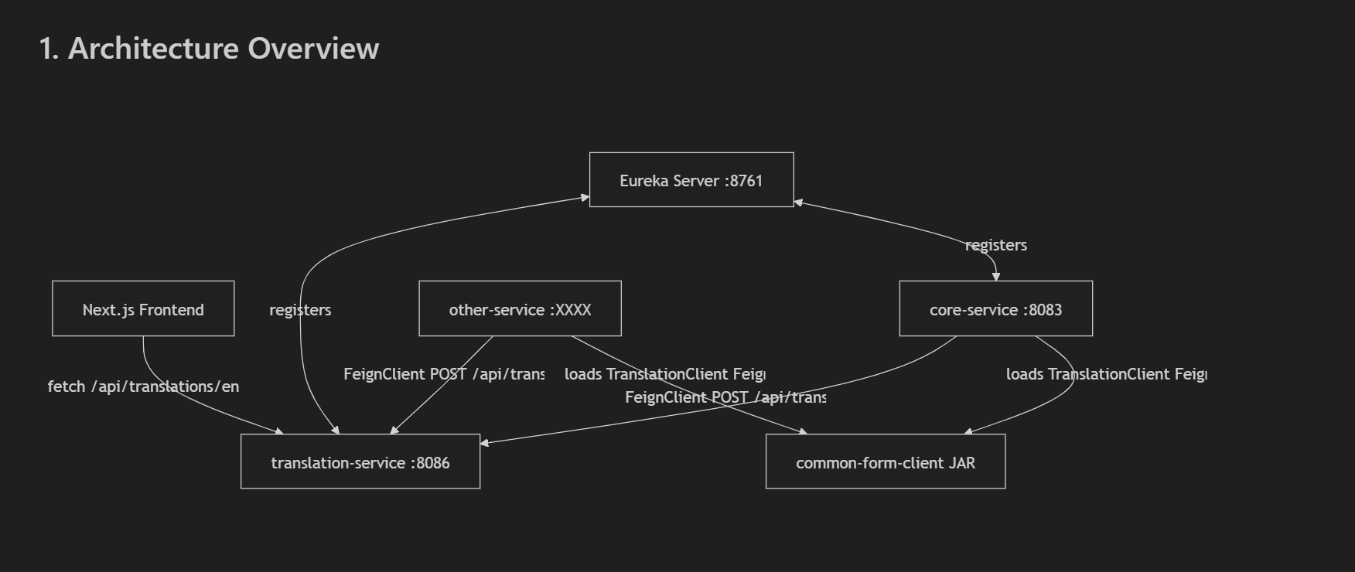
Services and their roles
Service | Port | Role
eureka-server | 8761 | Service registry — all services register here
translation-service | 8086 | Stores all translatable text in DB; exposes REST API
core-service | 8083 | Business service; auto-registers translations on entity save
common-form-client | (shared JAR) | Shared library providing  TranslationClient, @TranslatableField, and  TranslationEntityListener

